Timbre Study Guide
Test on:
_________________________
1st Grade

Timbre: The unique sound and instrument or voice makes.

Brass family: To belong to the brass family, an instrument must make sound by the musician blowing air into it while buzzing their lips (vibrating the lips).
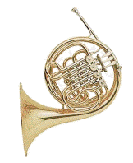
Highest sounding brass

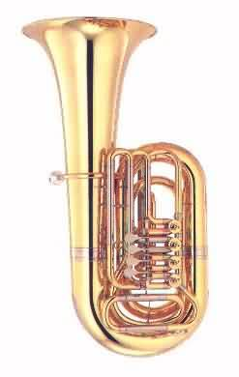
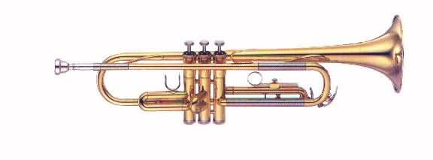
Lowest sounding brass

Trumpet

French Horn

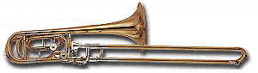

Tuba
Trombone

Percussion Family: You must hit, shake, scrape or rub and instrument in this family in order to make sound.
Examples: Drum, triangle, maracas, xylophone, cymbals, etc.

*Bonus*
Brass instruments are made from several different metals, but mostly brass, which is where it gets its name!

