Timbre Study Guide
Test On:
__________________________
2nd Grade

Timbre: The unique sound and instrument or voice makes.

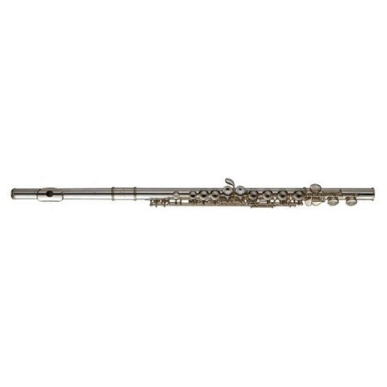
Woodwind family: To belong to the woodwind family, an instrument must make sound by the musician blowing air into it or blowing air across a reed (double or single).

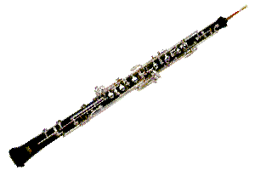
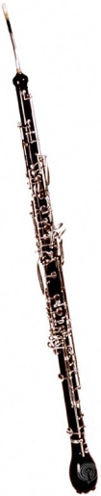
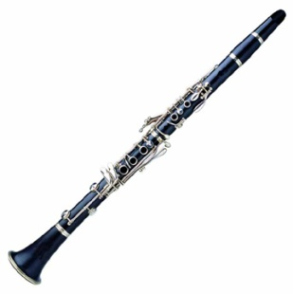
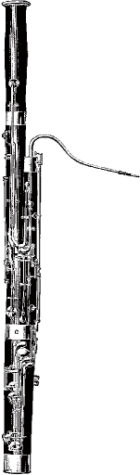
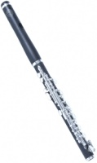
Highest sounding woodwind

Piccolo
Just Air

Lowest sounding woodwind

Flute
Just Air
Oboe
Double Reed
Clarinet
Single Reed
English
Horn
Double Reed
Bassoon
Double Reed

Double Reed: Two pieces of cane tied together (Bassson, English Horn, Oboe)
Single Reed: One piece of cane placed on the instrument’s mouthpiece (clarinet)
Percussion Family: You must hit, shake, scrape or rub and instrument in this family in order to make sound.
Examples: Drum, triangle, maracas, xylophone, cymbals, etc.
Brass Family: You must buzz your lips and blow air to make sound on and instrument in this family.
Examples: Tuba, Trombone, French Horn, Trumpet

*Bonus*
Saxophone is also a woodwind instrument, but not often seen or used in the symphony orchestra unless they are a special guest. You will see this woodwind instrument most often in bands, marching bands and jazz bands.

